Instructions for abstract preparation

Vozárová Vlasta¹ – Other Author(s)²

¹Department of Physics, Slovak University of Agriculture in Nitra
Tr. A. Hlinku 2, 949 76 Nitra, Slovakia
vlasta.vozarova@uniag.sk

²Other affiliation(s)
Address, Postal Code, City, Country
E-mail

Abstracts (in English) should not exceed two pages of this template A4 (210 × 297 mm), using Arial, single line. The margins, as shown in this template have the following dimensions: top – 35 mm; bottom – 25 mm; left – 25 mm; right – 25 mm.
The following structure should be kept: Title, Authors and Affiliations, text of Abstract, Acknowledgements and References – in alphabetical order (reference example: Vozárová, 2014). Equations should be numbered.
Description of the table should be above the table and description of the figure is below the figure as in this template:

Table 1: Text…
Text | Text
Text | Text

Text text text text text text text text text text text text text text text text text text text text text text, text text text text text text text text text text text text text text text text text text text text text text...

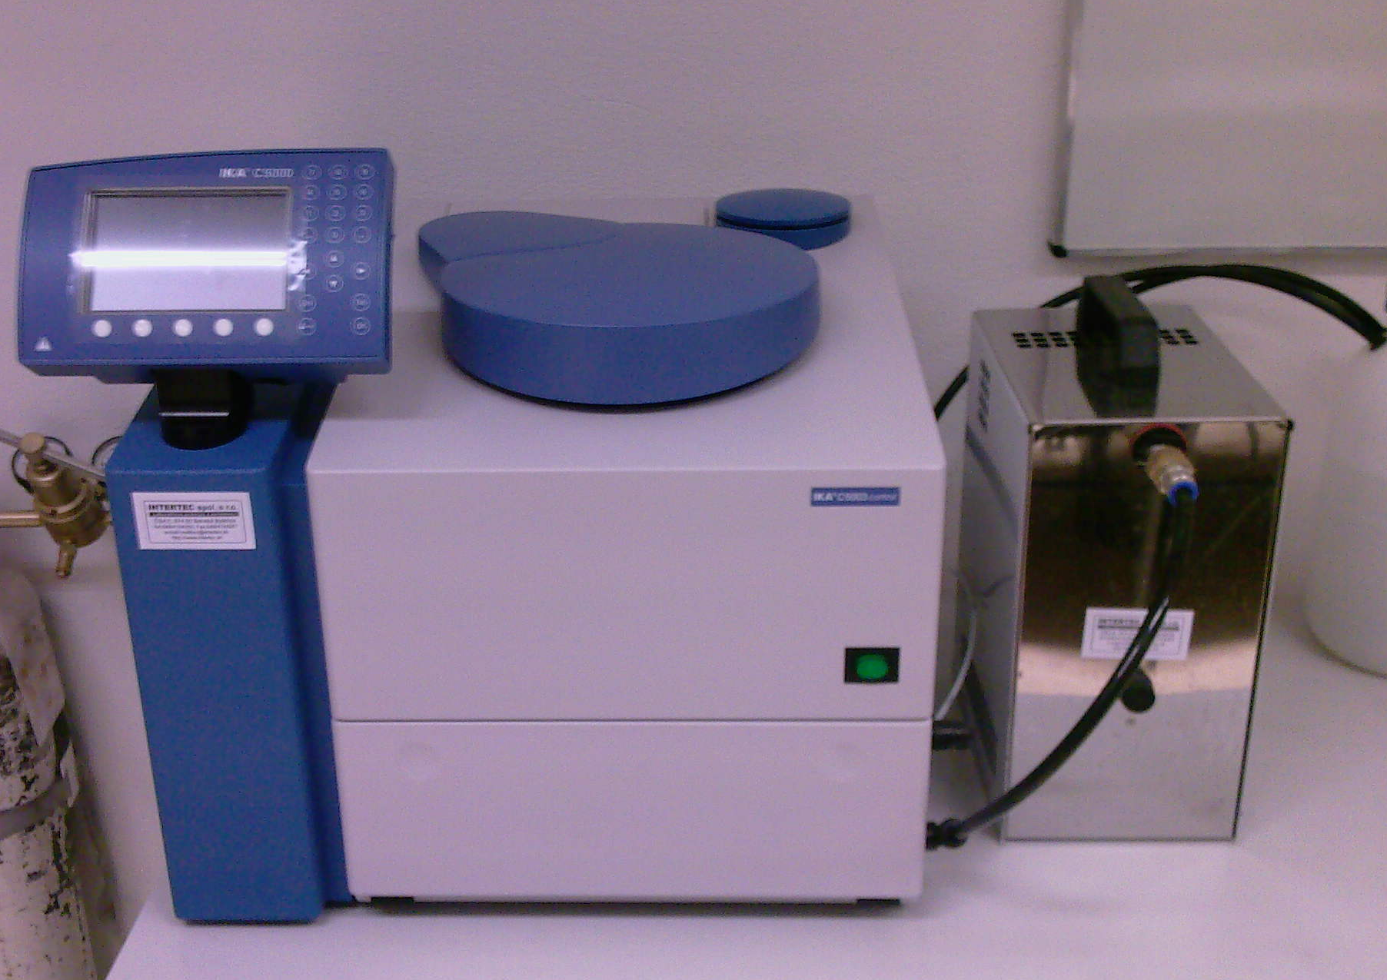

Figure 1: Calorimeter….

Text text text text text text text text text text text text text text text text text text text text text text...

acknowledgements
This work was co-funded by …

References
Reference to a journal publication:
- VAN DER GEER, J. – HANRAADS, J. A. J. – LUPTON, R. A. 2010. The art of writing
scientific article. Journal of Scientific Communications, 163, p. 51–59.
Reference to a book:
- STRUNK, W., Jr. – WHITE, E. B. 2000. The elements of style. 4th ed., New York : Longman.
Reference to a chapter in an edited book:
- METTAM, G. R. – ADAMS, L. B. 2009. How to prepare an electronic version of your article. In JONES, B. S. – SMITH, R. Z. (Eds.) Introduction to the electronic age. New York :
E-Publishing Inc., p. 281–304.

